**Unit 3: Linear Equations and inequalities**

**Lesson 4: Parameters of Linear Equations**

**Objectives:**

* **I can identify the parameters for a linear equations from graphs, tables and equations.**
* **I can write linear equations to represent relationships between variables looking at graphs, tables, and solve word problems.**
* **I can write linear equations for horizontal and vertical lines.**

**Agenda:**

* **Video**
* **Use your skills**
* **Use all your skills together**
* **Challenge yourself**

**Vocabulary:**

* **Linear equation, x,y coordinates, rate of change, initial value, vertical line, horizontal line, undefined slope.**

**Focus Questions:**

1. **What is the difference between slope and rate of change, and y-intercept and initial value?**
2. **What is the slope and rate of change for horizontal and vertical lines?**

**Web Support**

* [**https://www.youtube.com/watch?v=A6J8N2Q1ajY**](https://www.youtube.com/watch?v=A6J8N2Q1ajY)
* [**https://www.youtube.com/watch?v=Qo1_xkv2w_M**](https://www.youtube.com/watch?v=Qo1_xkv2w_M)
* [**https://www.youtube.com/watch?v=u9YZxBh1AxQ**](https://www.youtube.com/watch?v=u9YZxBh1AxQ)

**Homework: Finish your practice and continue working on the Regents Review. All Test corrections are due by 11-5th.**

**Quiz next block on lesson 1 and lesoon 2. Be preapred.**

[](https://www.bing.com/images/search?view=detailV2&ccid=Ecw61Ix5&id=793CE5F43E7444CCDC80BF3DC500027ADC7637BC&thid=OIP.Ecw61Ix5KDag_tqTojJH4wEsB_&q=quiz&simid=607989481997140850&selectedIndex=85)**Name: __________ Date: _______**

**Quiz 1 Unit 3 Linear Equations**

**Rearrange each of the following equations from standard form to slope intercept form (y=mx+b). Then Identify the slope and y-interept for each.**

$a) 3y-3x=15$ $b) 2y+5x=-8$

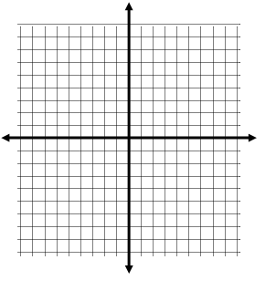(C) $Given the following linear equation:$

$$-\frac{3}{2}y=-6-x$$

*Graph the above equation:*

1. The Ace Cell Phone Company charges a flat monthly fee of $22.00 for a cell phone and $.20 per minute for long distance calls.
2. Write a linear model that represents the total cost per month, C, and the number of minutes, m, of long distance calls you make.
3. What is the slope of the linear model? What does it represent in the context of this problem?
4. What is the y-intercept? What does it represent in the context of this problem?
5. If you make 25 minutes of long distance calls per month, what will it cost for 1 **year**?

**Do Now:**

1. **Identify the parameters (slope and yintercept) of the following linear equations and write the equation in the slope-intercept from.**
2. $x+2y=6$**b. $3y+12=5x$**
3. **You opened a bank account to pay your bills. You had $200 in the account when you opened it, and every month you lose $ 20 to pay for your phone bill.**
4. What is the average rate of change and initial value?
5. Write a linear equation in the slope- intercept form to represent how much money (m) you have in your account after (n) months?

**Notes: Writing Equations:**

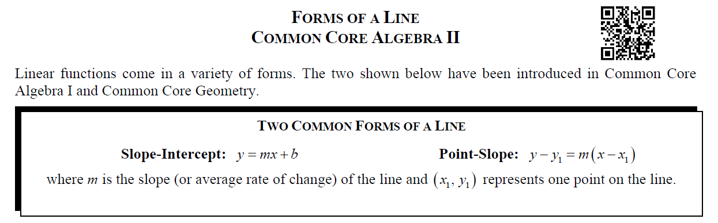

1. 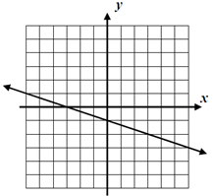 **B)**.

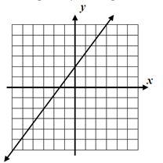

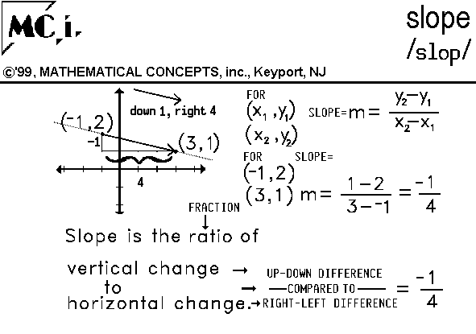**Average Rate of Change = Slope: Use the slope formula.**

1. **Find the average rate of change between the two points, then write an equation for each.**

**Write an equation of a line in point slope form:**  The line that passes through (2,5) and (5, 17)**.**

**Your turn:**

**Write an equation of a line in point slope form:**  The line that passes through $\left(2,-7\right) and (-1,6)$

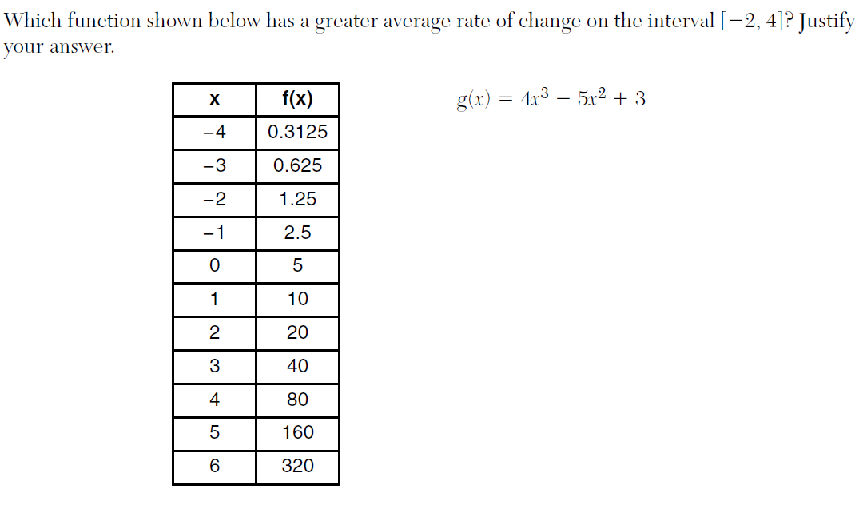

**Please note: interval: [-2, 4] means they only provided you with x values;**

**You still have to find the coressponding y value to each, then find the average rate of change for each function:**

**( -2, ?)**

**(-4, ?)**

**Special Lines: Graph the 4 equations on the same coordinate plane.**

Be sure to label each line!

a) y = 2

b) y = -4

c) x = 5

d) x = - 4

**Write an equation of a line that passes through these points:**

|  |  |
| --- | --- |
| 1. The line that passes through (1, -4) and has a slope of 0. | 1. The line that passes through (-3,2) and (-3,-1) |

**Name: _________________ Date: _______**

**Homework 3-4:**

1. 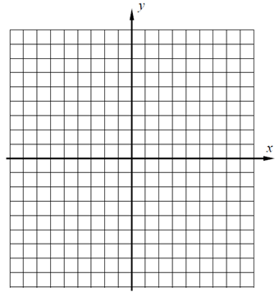Rewrite the equation in the slope-intercept form, identify the parameters, and use them to graph

$$2y-3x=10$$

Slope:__________ y-intercept:_________

1. A line that passes through (2,3) and has a slope of -3. Must provide both forms:
2. A line that passes through (2,3) and (4,4). Must provide both forms:
3. A gym is offering a deal to new members. Customers can sign up by paying a registration fee of $200 and a monthly fee of $39.
4. Write a linear equation in the slope-intercept form that represents how much money they need to pay over time.
5. What are the parameters of this linear equation and what do they represent in the context of the story.

**3)- 4)**

